Project: Net Guard – Threat Detection Bot

1. Introduction
The Threat Detection Bot is a module of the Net Guard system designed to monitor network traffic in real-time and detect suspicious activities such as port scanning and abnormal bandwidth usage. The system generates alerts and stores logs for further analysis.

2. Objectives
- Monitor real-time network traffic
- Detect unauthorized IP scanning (Port Scan)
- Identify high bandwidth anomalies
- Generate alerts for suspicious activities
- Store logs for future analysis

3. Functional Requirements
- The Packet Sniffer module captures network packets in real-time.
- The Packet Sniffer module monitors incoming and outgoing traffic continuously.
- The Detection Engine detects multiple requests from the same IP within a short duration.
- The Detection Engine identifies abnormal bandwidth usage.
- The Detection Engine classifies traffic as normal or suspicious.
- The Alert System triggers alerts when suspicious activity is detected.
- The Database module stores detected threats and logs for further analysis.

4. Non-Functional Requirements
- The Threat Detection Bot system processes data in real-time (within 2 seconds delay).
- The Threat Detection Bot system is scalable for multiple users/devices.
- The API layer ensures secure data transmission and communication.
- The Threat Detection Bot system is highly available and reliable.
5. Flowchart (System Workflow)

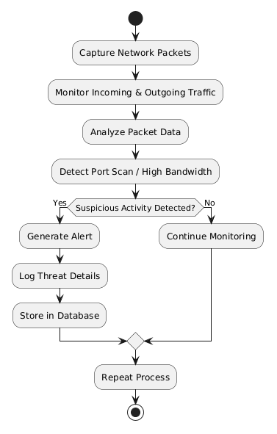

6. Conclusion
The Threat Detection Bot provides real-time monitoring and detection of suspicious activities in the network. This document defines the system functionality clearly before development.

7. Annexure

- Glossary (Terms Meaning)

• Packet Sniffer – A module that captures data packets flowing through the network
• Detection Engine – The main component that identifies suspicious activities
• Port Scanning – When an IP address checks multiple ports (possible attack sign)
• Bandwidth – The speed of data transfer in the network
• Alert System – Sends alerts when suspicious activity is detected
• Logs – Stored records of system activities

- Assumptions

• The system has continuous access to the network
• Required permissions are available to run the system
• The system has enough resources for real-time processing

- Constraints

• High network traffic may slow down the system
• Detection accuracy depends on defined rules and thresholds
• Limited hardware may affect performance

- Future Enhancements

• Use Machine Learning for better detection
• Add a real-time monitoring dashboard
• Integrate Email/SMS alerts
• Detect advanced attacks like DDoS and malware

- References

• Basic Network Security concepts
• Packet analysis techniques
• Threat detection methods

